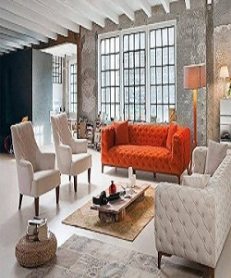

Lounge Sofa

$196.07

Availability: In stock

Description

The light and fresh design, tapered legs, and oatmeal tweed upholstery of this seating collection create a stylish look that embraces vintage flair and modern living. Complete your living room decor with these chic seating options. Back cushions and roll pillows are loose. Walnut Black wood finish.